1. **INTRODUCTION**

**1.1 Project Overview:– TrafficTelligence: Advanced Traffic Volume Estimation with Machine Learning**

TrafficTelligence is a smart system designed to estimate and predict traffic volume using machine learning. It uses data from the past, like how many vehicles were on the road at different times, to understand traffic patterns. It also looks at things like weather, holidays, and local events that might affect traffic. By studying all these factors together, the system can give accurate predictions about how busy the roads will be. This helps traffic managers make better decisions and reduce traffic jams.

The system is built using Python and several useful libraries for data analysis and visualization. It cleans and prepares the data before training machine learning models to make predictions. Charts and graphs are created to help users understand the data easily. The results are shown on a simple web dashboard, which is created using Python web frameworks like Flask or Django.

TrafficTelligence helps city planners make smarter choices when building or improving roads. It can also give real-time updates to commuters, warning them about busy roads or delays. The system can keep learning over time as it gets more data, so the predictions become even better. It supports smart city goals and helps create smoother, safer travel experiences. With this tool, cities can plan for the future and manage traffic in a smarter way.

**1.2 Purpose of the Project:**

The purpose of the **TrafficTelligence** project is to develop an intelligent system that can **accurately estimate and predict traffic volume** using machine learning techniques. This helps in making better decisions for **traffic control**, **urban planning**, and **commuter convenience** by analyzing various factors like historical traffic data, weather, and events. The goal is to reduce congestion, improve road safety, and support the development of smart cities.

**Key Objectives of the Project:**

1. Collect and preprocess traffic-related data from various sources including sensors, weather data, and event schedules.
2. Analyze historical traffic patterns to understand peak hours, congestion points, and seasonal trends.
3. Apply machine learning models to predict future traffic volume with high accuracy.
4. Visualize traffic trends and predictions using charts and graphs for easy interpretation.
5. Build a user-friendly web interface to display real-time traffic predictions and insights.
6. Integrate external factors like weather and public events into the prediction model.
7. Enable traffic authorities and planners to make informed decisions based on data.
8. Provide alerts and suggestions to commuters for better route planning.
9. Continuously update and retrain models to improve prediction accuracy over time.
10. Support smart city initiatives by offering scalable and adaptive traffic solutions.

**2. IDEATION PHASE**

2.1 Problem Definition

2.2 Project Planning

2.3 Brainstorming

**3. REQUIREMENT ANALYSIS**

3.1 Functional Requirements

3.2 Non Functional Requirements

3.3 Technical Requirements

3.4 Technology Stack

**4. PROJECT DESIGN**

4.1 System Architecture

4.2 Key Components

4.3 Data Collection

4.4 Data Flow Diagram

**5. PROJECT PLANNING & SCHEDULING**

**5.1** Project Planning

**6. FUNCTIONAL AND PERFORMANCE TESTING**

**6.1** Performance Testing

**7. RESULTS**

**7.1** Output Screenshots

**Application Output:**

The complete execution of the Traffictelligence application is shown in the images step by step as shown below.

**Step 1:** Run the app.py code and you will get a link in terminal as <https://127.0.0.1.5050> to access web page and to do the other process.

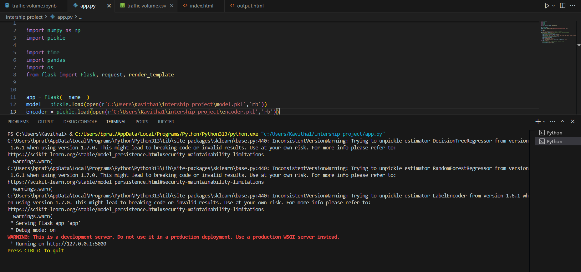

**Step 2:** Click on that link a web page will be open in the web browser.

Enter the following details below.

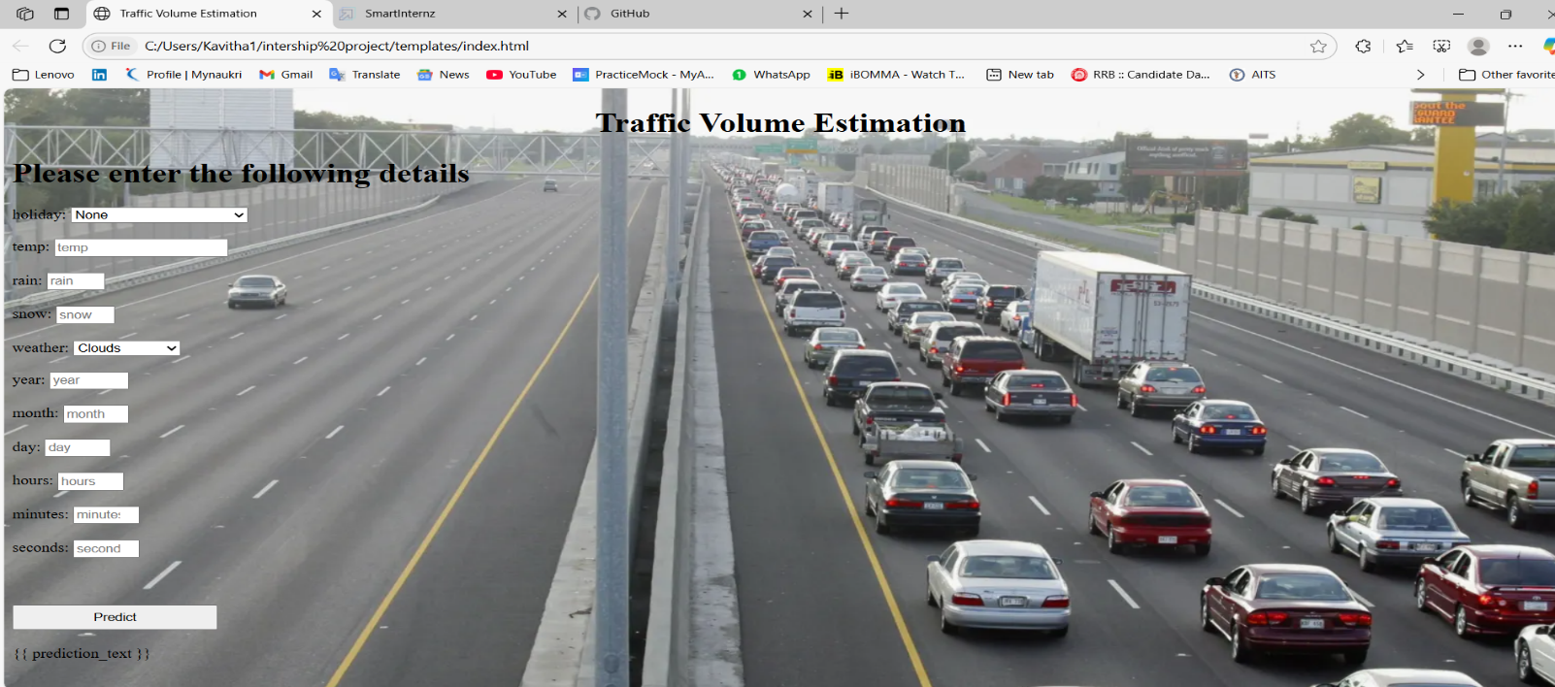Then click predict

Step 3: The output will be displayed.

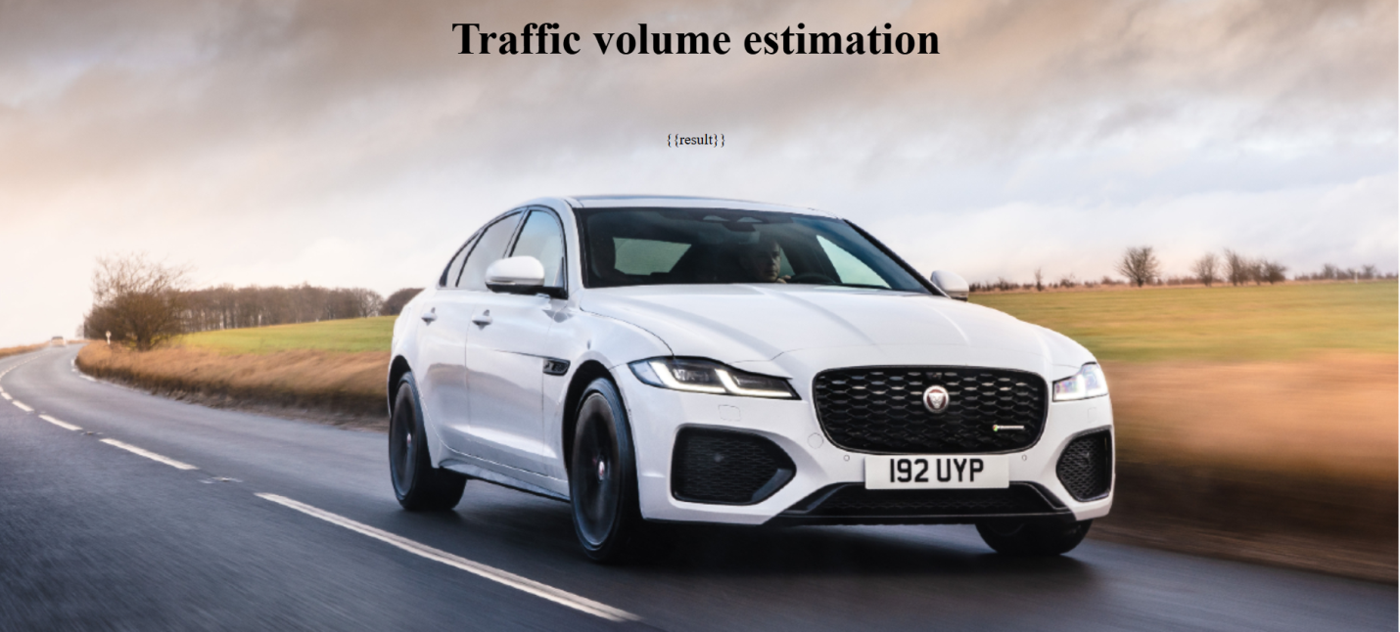

**8. ADVANTAGES & DISADVANTAGES**

* 1. **ADVANTAGES**
* Accurate Traffic Predictions
* Improved Traffic Management
* Enhanced Commuter Experience
* Integration of External Factors
* Data-Driven Decision Making
* User-Friendly Interface
* Scalable and Adaptable
* Cost-Effective Solution
  1. **DISADVANTAGES**
* Data Dependency
* High Initial Setup Effort
* Complex Model Maintenance
* Risk of Overfitting or Underfitting
* Infrastructure Limitations
* Not Suitable for Unpredictable Events
* Learning Curve for Users

**9. CONCLUSION**

The Traffictelligence project demonstrates the potential of intelligent traffic management systems to revolutionize urban mobility. By leveraging advanced technologies such as artificial intelligence, real-time data analytics, and smart sensors, this project provides an efficient, scalable solution to address traffic congestion, improve road safety, and reduce environmental impact.

Going forward, Traffictelligence can be expanded with machine learning models for predictive traffic analysis, integration with emergency response systems, and user-friendly interfaces for public and governmental use. With continued development, it has the potential to become a cornerstone in the future of smart cities, promoting sustainability, efficiency, and enhanced quality of life for urban populations.

**10.Future Scope**

**Smart City Connection**: Can be used as part of smart cities to manage traffic better across the whole city.

**Traffic Prediction**: Can predict traffic jams and busy times using past data and AI.

**Talk with Vehicles**: In the future, it can communicate directly with smart or self-driving cars.

**Eco-Friendly**: Can help reduce pollution by cutting down on traffic and wait times.

**Mobile App**: A user app can give drivers live traffic updates and best route suggestions.

**Use in Other Cities**: Can be improved and used in different towns or cities easily.

**Quick Accident Alerts**: Can detect accidents or road problems and send alerts right away.

**Support Self-Driving Cars**: Can help self-driving cars move safely and smartly in traffic.

**11.APPENDIX**

Git-Hub Repository Link:

https://github.com/bandikavitha/TrafficTelligence

Dataset Link:

https://drive.google.com/file/d/1iV5PfYAmI6YP0_0S4KYy1ZahHOqMgDbM/view?pli=1

Project Demo Link:

https://drive.google.com/file/d/1tAIXAQQCtEHAkc3Mx_p1KqmW1kSUfpHd/view?usp=sharing